**LAGOS STATE POLYTECHNIC**

**DEPARTMENT OF COMPUTER ENGINEERING**

**4 MONTHS REPORT ON STUDENTS INDUSTRIAL WORK EXPERIENCE SCHEME (SIWES)**

**UNDERTAKEN AT: FOLADTECH IT SOLUTIONS, MARYLAND**

**PRESENTED BY: ADEBOWALE HAFSAH OLAMIDE**

**MATRIC NO: 2102061023**

**SIWES SUPERVISOR: ENGR AJAYI A.O**

**SUBMITTED TO: THE DEPARTMENT OF COMPUTER ENGINEERING**

**IN PARTIAL FULFILMENT OF THE AWARD OF NATIONAL DIPLOMA (ND) IN COMPUTER ENGINEERING.**

**FROM:**

DECEMBER 5TH, 2022 TO MARCH 23RD, 2023

**CERTIFICATION**

This is to certify that this report was written by I, **ADEBOWALE HAFSAH OLAMIDE** with **MATRIC NUMBER: 2102061023** of the **DEPARTMENT OF COMPUTER ENGINEERING, LAGOS STATE POLYTECHNIC, IKORODU** on my 16 weeks SIWES training at **FOLADTECH SOLUTIONS** situated at **MARYLAND LAGOS.**

**_________________________ _____________________**

ADEBOWALE O. HAFSAH DATE

(STUDENT)

___________________________ _____________________

ENGR A.O AJAYI DATE

(SUPERVISOR)

___________________________ _____________________

ENGR A.A AKINLEYE DATE

(HOD)

**DEDICATION**

This report is dedicated foremost to Almighty for his favour, mercies and grace upon me during my four (4) months SIWES programme at FOLADTECH IT SOLUTIONS.

I would also like to dedicate it to my mum and siblings for their undenying love and support and to my ever supportive friends and colleagues for their contributions towards making my SIWES training a fun and successful one.

**ACKNOWLEDGEMENT**

My appreciation goes to the industrial Training Fund for their foresight in putting this program in place.

I am grateful to Foladtech IT Solutions for providing me with the necessary skills to be exposed in my field. I also want to say a big thank you to my industry based supervisor Engr. Obasan Daud and my able colleague for making my stay at Foladtech IT Solutions a memorable and knowledge filled one. I’m so grateful to you all.

To my parents and siblings thank you all for your moral and financial support.

I am deeply indebted to the Almighty, the giver of all wisdom, knowledge and understanding, without whom I would have achieved nothing .

Finally to my Institution based supervisor for his support and to my other friends and colleagues. Thank you and God bless you.

**ABSTRACT**

This report presents the experience gained during my four (4) months of siwes training undertaken at Foladtech Solutions Maryland, Lagos.

My training was on web design and development. I acquired practical knowledge on how to design a website.

This report discusses the technical skills gained during the training period and justifying the relevance of the scheme in equipping students with needed technical competence to thrive in the real world.

**TABLE OF CONTENT**

**TITLE PAGE**

CERTIFICATION**…………………………**I

DEDICATION**............……………………**II

ACKNOWLEDGEMENT**.......……………**III

ABSTRACT**.............………………………**IV

TABLE OF CONTENT**................................**V

**CHAPTER 1**

BREIF INTRODUCTION OF SIWES**……………………….……………**1.0

ABOUT ORGANISATION**………………………………………………..**1**.**1

ORGANISATION ORGANOGRAM**……………………………………..**1**.2**

**CHAPTER 2**

DEPARTMENTS/ASSIGNMENTS**………………………………………2.0**

**CHAPTER 3**

**DETAILED EXPERIENCE GAINED…………………………………3.0**

DEFINITION OF TERMS**………………………………………………..3.1**

SOFT SKILL ACQUIRED**……………………………………………….3.2**

**CHAPTER 4**

**OBSERVATION/RECOMMENDATION**

CHALLENGES ENCOUNTERED**……………………………………..4.0**

SOLUTIONS**……………………………………………………………..4.1**

OBSERVATION**…………………………………………………………4.2**

RECOMMENDATION**………………………………………………….4.3**

**CHAPTER 1**

**1. 0 BRIEF INTRODUCTION OF SIWES**

**SIWES: (Student Industrial Work Experience Scheme)**

Since the aim of our national policy in education is to build a strong and self- reliant nation, from the government’s decree No.47 of 8th October, 1971 as amended in1990, which led to the establishment of Industrial Training Fund (ITF) in 1973/1974 and through the formation of this body (ITF), in the year 1993/1994 and through the formation of this body (ITF), in the year 1993/1974 SIWES was formed. In Nigeria, the current form of Cooperative Education is known as the Students Industrial Work Experience Scheme (SIWES).

The Students Industrial Work Experience Scheme (SIWES) is a planned and supervised training intervention based on stated and specific learning and career objectives and geared towards developing the occupational competencies of the participants. The aim is make education more relevance and also to bridge the science-related disciplines in tertiary institutions in Nigeria.

SIWES forms part of the approved minimum academic standards in the institutions, and is a core academic requirement carrying fifteen (15) credit units. This requirement must be met by all students in various disciplines before graduation.

**BODIES INVOLVED IN SIWES**

The main bodies involved in Student Industrial Work Experience Scheme are;

The tertiary institutions and the Federal Government through the Industrial Training Fund (ITF).

Other supervising agencies include:

1. National University Commission (NUC)
2. National Board for Technical Education (NBTE)
3. National Council for colleges for Education (NCCE)
4. Industry/Employers (NECA, NACCIMA, MAN, Government Establishments)
5. Tertiary Institutions (Universities, Polytechnics, Colleges of Education)
6. Student Trainees (Engineering, Science, Technology, NCE Technical).

The functions of these agencies above are to:

1. Ensure adequate funding of the scheme
2. Establish SIWES and accredit SIWES unit in the approved institutions
3. Formulate policies and guideline for participating bodies and institutions as well as appointing SIWES coordinators and supporting staff
4. Supervise students at their places of attachment and sign their log book and ITF forms.
5. Vet and process students Log books and forward same to ITF area office
6. Ensure payment of all allowances for the students and supervisors.

**AIMS AND OBJECTIVES OF SIWES:**

The specific objectives of SIWES were summarized by the federal government as follows:

1. To provide students with an opportunity to apply their knowledge in real work and actual practice.
2. To make the transition from school to the world of work easier and to enhance students contacts for later job placement.
3. Advanced countries, with over 100 years of sustained industrial development and requisite technical and human infrastructure, have been able to adequately implement industrial training for their students.
4. They also include providing a structural attachment program with emphasis applications, management and hands-on experience for students to apply knowledge acquired.
5. It also aids students to acquire practical skill in other to strengthen their work value.

**1.1** **ABOUT FOLADTECH IT SOLUTIONS**

Foladtech IT solutions is located at No 8, Salahdeen Close, Mende, Maryland,Lagos. It is an indigenous information technology company. It is equipped with the newest technology available in Software engineering, Web design and development and also Mobile App development e.t.c. The campany was founded in 2015 by its current Manager/CEO in person of Mr Obasan Daud.

Foladtech IT solutions focuses on quality, innovation & speed. They utilise technology to bring results to grow their clients businesses. FOLADTECH IT prides itself with user-friendly and professional websites that are valuable to any audience that visits. Throughout the year FOLADTECH IT has been able to create stunning designs in multiple verticals while allowing their clients to obtain an overall better web presence.

**CORE SERVICES AT FOLADTECH IT SOLUTIONS**

1. Computer repair and maintenances
2. Networking
3. Software development
4. Sales of computer system and Gadgets
5. Web design / development.
6. Consultancy.

**ORGANISATION ORGANOGRAM**

**Managing Director**

**Remote Workers**

**Graphics Designers**

**Web Designers / Frontend Developers**

**Backend Developers**

**Full-Stack Developers**

**IT Students / Trainees**

**CHAPTER 2**

**2.0 DEPARTMENT AND ASSIGNMENTS**

**WEB DESIGN DEPARTMENT**

This department was where my Industrial Training took place where i was grounded and expose to the website world especially the creation of websites taking me step by step with practical all through the process.There are various personnelin the department namely:

**Web Designers / Frontend Developers:** are two important responsibilities given to a certain set of people. Web Designers convert the PSD files designed by the Graphics designers to web pages using HTML, CSS etc. They can also add their own creativity to the web pages. The Frontend Developers depend on the Backend Developers to write the Application Programming Interface (API) for them, they render the API to the User Interface in a presentable and User Friendly manner. In other words, the Web Designers / Frontend Developers are in charge of the part of the side of the web application that is visible to the User of the application. The common programming languages used in this Unit of the Company include Hypertext Markup Language (HTML), Cascading Style Sheet (CSS), JavaScript/TypeScript. They also use popular frameworks like Bootstrap, Angular, React etc.

1. **Backend Developers:** are in charge of building API and managing the database of applications. They are very skillful in developing a clean architectural code or following a complex architecture given to them by the Project manager. They work alongside with the Frontend Developers and the Designers to ensure that the Application reaches the production stage. To enhance their problem solving skills, they always spend most of their leisure time to learn Data Structure and Algorithm.
2. **Full-stack developers:** are the personnel that start from the very scratch (“Web Development 101”) and keep on learning all the skills from all aspect of the Web Development industry till they become very skillful in every units involve in the Web Development industry. Note that this does not just happen overnight, it takes adequate amount of time base on what I noticed from the personnel who are currently Full-Stack Developers. They can easily handle intermediate projects and implement it from the very beginning to the end which includes the Designing, Consuming of Data as a Frontend Developer and Writing the API as a Backend Developer. They have the experience of working in all other units of the organization. Most of the Personnel working towards this unit or working in this unit has a dream of becoming a Freelancer or a dream of creating their own IT Company later in the future. So, they do not want to be limited in any form.

**PROJECT WORKED ON DURING MY ATTACHMENT**

* RE-DESIGNING NETFLIX LANDING PAGE: Together with my colleagues in the department, I was able to clone Netflix landing page using the knowledge of HTML and CSS.
* DESIGNED A CALCULATOR: I worked alongside my industry-based supervisor and my colleagues to build a non-Functional calculator.
* DESIGNED AWEB PAGE HERO-SECTION: Hero section is the fore front page in a website, it more or less like a landing page. The whole team worked together to come up with the design.
* SIGN-UP PAGE DESIGN: The team designed a sign-up page for a website.

**CHAPTER 3**

1. **DETAILED EXPERIENCE GAINED**.

**DEFINITION OF TERMS**

The following are terms that were made use of, in this department

**WEBSITE:**

A website is a set of related webpages containing content such as texts, images, videos, audios, etc. A website is hosted on at least one web server, accessible via a network such as the internet or a private LAN through an internet address known as a URL (Universal Resource Locator). A publicly accessible websites collectively constitutes the World Wide Web (WWW).

**WEBPAGE:**

A webpage is a document, typically written in plain text interspersed with formatting instructions of hypertext nark up language (HTML, XHTML). A webpage may incorporate elements from other websites with suitable anchors. Webpages are accessed and transported with the hypertext transfer protocol (HTTP), which may occasionally employ encryption (HTTP secure, HTTPS) to provide security and privacy for the use of the webpage content. The user’s application often a web browser renders the page content according to its HTML mark-up instructions into a display terminal.

**HTTP:**

This stands for **“**Hyper Text Transfer Protocol**”** which is the set of rules for transferring files (text, graphic, images, sound, video, and other multimedia files) on the World Wide Web.

**URL:**

This stands for **“**Uniform Resource Locator**”** and as the name suggests, it provides a way to locate a resource on the web, the hypertext system that operates over the internet.

**HTML AND ITS PROPERTIES**

HTML stands for **“H**yper**t**ext **M**ark-up **L**anguage**”**, and it is the most widely used language to write Web Pages.

* **Hypertext** refers to the way in which Web pages (HTML documents) are linked together. Thus, the link available on a webpage is called Hypertext.
* As its name suggests, HTML is a **Markup Language** which means you use HTML to simply "mark-up" a text document with tags that tell a Web browser how to structure it to display.

Originally, HTML was developed with the intent of defining the structure of documents like headings, paragraphs, lists, and so forth to facilitate the sharing of scientific information between researchers.

Now, HTML is being widely used to format web pages with the help of different tags available in HTML language.

**HTML TAGS:**

As told earlier, HTML is a markup language and makes use of various tags to format the content. These tags are enclosed within angle braces **<Tag Name>**. Except few tags, most of the tags have their corresponding closing tags. For example, **<html>**has its closing tag**</html>**and **<body>**tag has its closing tag **</body>**tag etc.

The following are the names of tags and their description.

|  |  |
| --- | --- |
| **Tag** | **Description** |
| <html> | This tag encloses the complete HTML document and mainly comprises of document header which is represented by <head>...</head> and document body which is represented by <body>...</body> tags. |
| <head> | This tag represents the document's header which can keep other HTML tags like <title>, <link>, <script language =”javascript”> etc. |
| <title> | The <title> tag is used inside the <head> tag to mention the document title. |
| <body> | This tag represents the document's body which keeps other HTML tags like <h1>, <div>, <p>, <table> etc. |
| <h1> | This tag represents a heading |
| <p> | This tag represents a paragraph. |
| <b>, <i>, <li>, <ul> | Bold, italic, list, unordered list |

**HTML TABLE:**

The HTML table model allows web designers to arrange data –text, preformatted text, images, links, forms, form fields, other tables, etc. into rows and columns of cells. It is defined with the <table> tag.

Table are divided into table rows with the <tr> tag. Table rows are divided into table data with the <td> tag. A table row can also be divided into table headings with the <th> tag.

Table data <td> are the data containers of the table. They can contain all sorts of HTML elements like text, images, lists, other tables.

**A SIMPLE HTML TABLE**

<!DOCTYPE html>

<html>

<style>

table, th, td {

border:1px solid black;

}

</style>

<body>

<h2>A basic HTML table</h2>

<table style="width:100%">

<tr>

<th>LAST NAME</th>

<th>FIRST NAME</th>

<th>NATIONALITY</th>

</tr>

<tr>

<td>ADEBAYO</td>

<td>TOPE</td>

<td>NIGERIAN</td>

</tr>

<tr>

<td>NANA</td>

<td>KWESI</td>

<td>GHANIAN</td>

</tr>

</table>

<p>To understand the example better, i have added borders to the table.</p>

</body>

</html>

**OUTPUT: A BASIC HTML TABLE**

|  |  |  |
| --- | --- | --- |
| **LAST NAME** | **FIRST NAME** | **NATIONALITY** |
| ADEBAYO | TOPE | NIGERIAN |
| KWESI | NANA | GHANIAN |

**To understand the example better, I have added a borders to the table.**

**CSS AND ITS PROPERTIES**

CSS stands for**”** **Cascading Style Sheet “**used for formatting html document. It is a style sheet language used for describing the presentation of a document written in a mark-up language.

**METHOD USED BY CSS IN FORMATTING HTML DOCUMENT**

1. **Inline Style:** It is used to apply a unique style to a single HTML element. An inline CSS uses the style attribute of an HTML element.
2. **Embedded / Internal Style:** It is used if one single page has a unique style. Internal styles are defined within the <style> element, inside the <head> section of an HTML page.
3. **External Style:** With an external style sheet, you can change the look of an entire website by changing just one file. Each page must include a reference to the external style sheet file inside the <link> element. The <link> element goes inside the <head> section. Also when using external css it is preferable to keep the css separate from your HTML. Placing CSS in a separate file allows the web designer to completely differentiate between content (HTML) and design (CSS). External CSS is a file that contains only CSS code and is saved with a “.css” file extension. This CSS is then referenced in your HTML using the <link> instead of <style> as earlier stated.

**CSS SELECTORS AND HOW THEY CAN BE USED**

CSS selectors are used to find or select HTML elements based on their element name,id or class

* **Element Selector:** The element selector selects elements based on the element name.
* **Id Selector:** The id selector uses the id attribute of an HTML element to select a specific element. The id of an element should be unique within a page, so the id selector is used to select one unique element. e.g. id=”hello” css #hello { color;red;}
* **Class Selector:** The class selector selects elements with specific class attribute. To select elements with a specific class, write a period (.) character followed by the name of the class. e.g. .center {text-align:center;}

**CSS RULES OVERRIDING**

1. Any inline style sheet takes the highest priority, so it will override any rule defined in <style>……</style> tags.
2. Any rule defined in <style>………</style> tags will override the rules defined in any external style sheet file.

**CSS COMMENTS**

To simply put comment inside a style sheet you use **“/*………..*/”**, you can use it to comment multi-line blocks in similar way as you do in c and c++ programming language.

**BACKGROUND AND FONT OF VARIOUS HTML ELEMENTS**

You can set the following background properties of an element.

1. **The background-color:** Is a property used to set the color background of an element.
2. **The background-image property:** is used to set the background image of an element.
3. **The background repeat:** Is used to control the repetition of an image in the background.
4. **The background position:** Is used to control the position of an image in the background.
5. **The background attachment:** Is used to control the scrolling of an image in the background.
6. **The background property:** Is used as a short hand to specify a number of other background properties.

**FONT WHICH ARE;**

1. **The Font-family property:** This is used to change the face of a font
2. **The Font-style property:** This is used to make a font italic or oblique.
3. **The Font-weight property:** This is used to increase or decrease how bold or light a font appears.
4. **The Font-size property:** This is used to increase or decrease the size of a font.

**TEXT DECORATION:**

This demonstrate how to decorate a text in css, the values are none, underline, over line, line through and blink.

**PROPERTIES OF HYPERLINK USING CSS**

1. The link signifies unvisited hyperlinks
2. The link visited signifies visited hyperlinks
3. The link hovered signifies an element that currently has the user’s mouse pointer hovering over it.
4. The link active signifies an element on which the user is currently clicking.

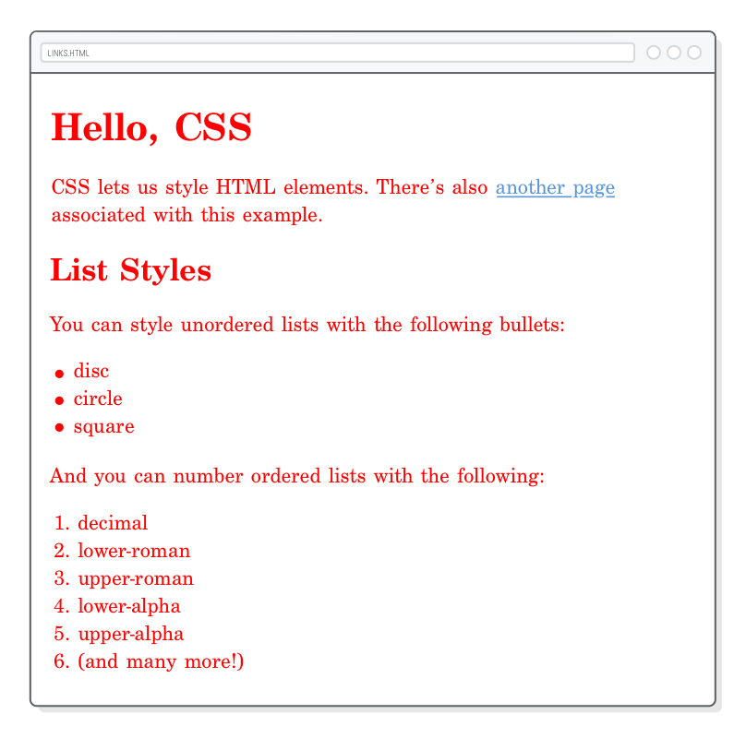

**Fig. *This is done using HTML Elements and CSS Color property.***

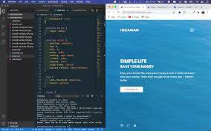

**Fig. *Image of a Hero-Section***

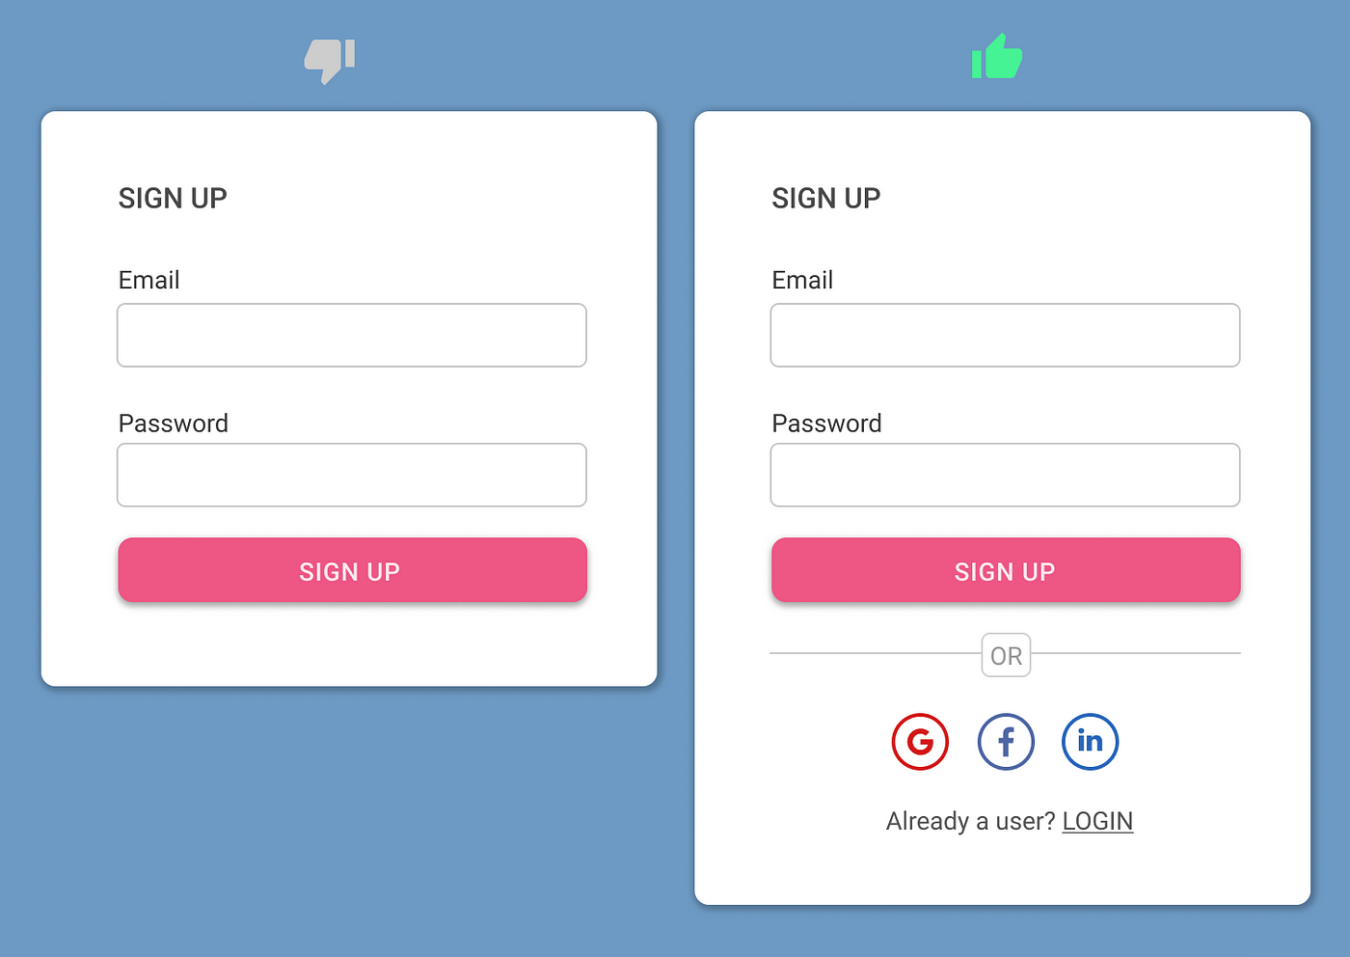

**Fig. *A Signup Page*.**

**3.2** **SOFT SKILLS ACQUIRED**

* Enhanced communication skills.
* Ability to identify and solve problems relating to web design.
* Decision making, critical thinking, organizing and planning.
* Ability to work with team.
* Enhanced teaching and effective learning skills
* Good customers services orientation skill

**CHAPTER 4**

**OBSERVATION/ RECOMMENDATION**

**4.0 CHALLENGES ENCOUNTERED**

* Lack of transportation fee.
* Lack of good facilities for web design.
* Lack of internet facility.
* Poor power supply
* Inability to understand the terminologies associated with web development.

**4.1 SOLUTION TO CHALLENGES ENCOUNTERED**

* Working when there is light.
* Getting a personal PC to work with.
* Asked questions.

**4.2 OBSERVATION**

My four (4) months SIWES at FOLADTECH SOLUTION was a huge success and a great time of acquisition of knowledge and skills. Through my training i was able to appreciate my chosen course of study even more, because i had the opportunity to blend the theoretical knowledge acquired from school with the practical hands-on application of knowledge gained here to perform very important tasks that contributed in a way to my productivity in the company. My training here has given me a broader view to the importance and relevance of Computer Engineering (Web Design Development) in the immediate society and the world as a whole, as I now look forward to impacting it positively after graduation. I have also been able to improve my communication and presentation skills and thereby developed good relationship with my fellow colleagues at work. I have also been able to appreciate the connection between my course of study and other disciplines in producing a successful result.

**4.3 RECOMMENDATIONS:**

* School should provide a place of attachment for student.
* Allowances should be paid to students during their programme.
* Supervisor should always visit student monthly in their various places of attachment.
* ITF should kindly increase the SIWES allowance paid to students.
* The duration for the SIWES program should be increased.